SIMATS ENGINEERING
ASSESSMENT TOOL 1
NAME:H.BHARANI REG NO:192524385 COURSE NAME: DESIGN AND ANALYSIS OF ALGORITHMS COURSE CODE: CSA0606

COURSE OUTCOME COVERED
CO2: Apply Brute Force technique to solve sorting, searching, Closest-Pair and Convex-Hull problems (BL1, BL2,BL3)
Assessment Tool Weightage: 40%
QUESTIONS: 10 Total Marks:100 Annexure A
ANALYTICAL PROBLEM SOLVING
Code of Conduct:
I ____________________ (Name / Reg No) certify that this submission is my original work and that I have adhered to the guidelines specified for this assessment.
I understand that any violation of academic integrity rules will result in disciplinary action. Signature of the student:
Annexure A
ANALYTICAL PROBLEM SOLVING
Q7. Linear Search – Analytical Problem
Given an unsorted dataset [23, 45, 12, 67, 34, 89, 10], apply Linear Search to find the element 34. Clearly interpret the problem and explain the search process step-by-step. Count the number of comparisons required to locate the element. Analyze the time complexity in best, average, and worst cases. Verify the correctness of the result. Interpret the efficiency of Linear Search in real-world scenarios.

Q7. Linear Search – Analytical Problem

1. Problem Statement
Given the unsorted dataset:
[23, 45, 12, 67, 34, 89, 10]
Use Linear Search to find the element 34. The search must check each element sequentially from the beginning until the required element is found.

2. Objectives
- Find 34 using Linear Search.
- Explain the search process step-by-step.
- Count the number of comparisons.
- Analyze best, average, and worst-case time complexity.
- Verify that the search result is correct.
- Understand the efficiency of Linear Search in real-world applications.

3. Inputs and Outputs
Input:
- Dataset = [23, 45, 12, 67, 34, 89, 10]
- Target = 34
Output:
- Element 34 is found.
- Position = 5th position
- Index = 4 using zero-based indexing.
- Number of comparisons = 5

4. Assumptions and Constraints
- The dataset is unsorted.
- Each element is checked sequentially.
- The search stops when the target is found.
- No sorting is performed before searching.
- Each comparison is assumed to take constant time, O(1).

5. Problem Analysis
Linear Search starts from the first element and compares each element with the target.
Dataset:
Position | Element | Comparison with 34 | Result
1 | 23 | 23 ≠ 34 | Continue
2 | 45 | 45 ≠ 34 | Continue
3 | 12 | 12 ≠ 34 | Continue
4 | 67 | 67 ≠ 34 | Continue
5 | 34 | 34 = 34 | Found
Therefore, 34 is found at position 5.

6. Mathematical Model
Let the dataset contain n elements:
Let the target element be x.
Linear Search checks:
for:
For this problem:
The target occurs at:
Therefore:

7. Algorithm Selection
Selected Algorithm: Linear Search
Reason for selection:
- Dataset is unsorted.
- Simple and easy to implement.
- No preprocessing or sorting is required.
- Suitable for small datasets.

8. Algorithm / Pseudocode
LinearSearch(A, n, target)

1. For i = 0 to n-1
2. If A[i] == target
3. Return i
4. Return -1
For the given dataset:
A = [23, 45, 12, 67, 34, 89, 10]
target = 34

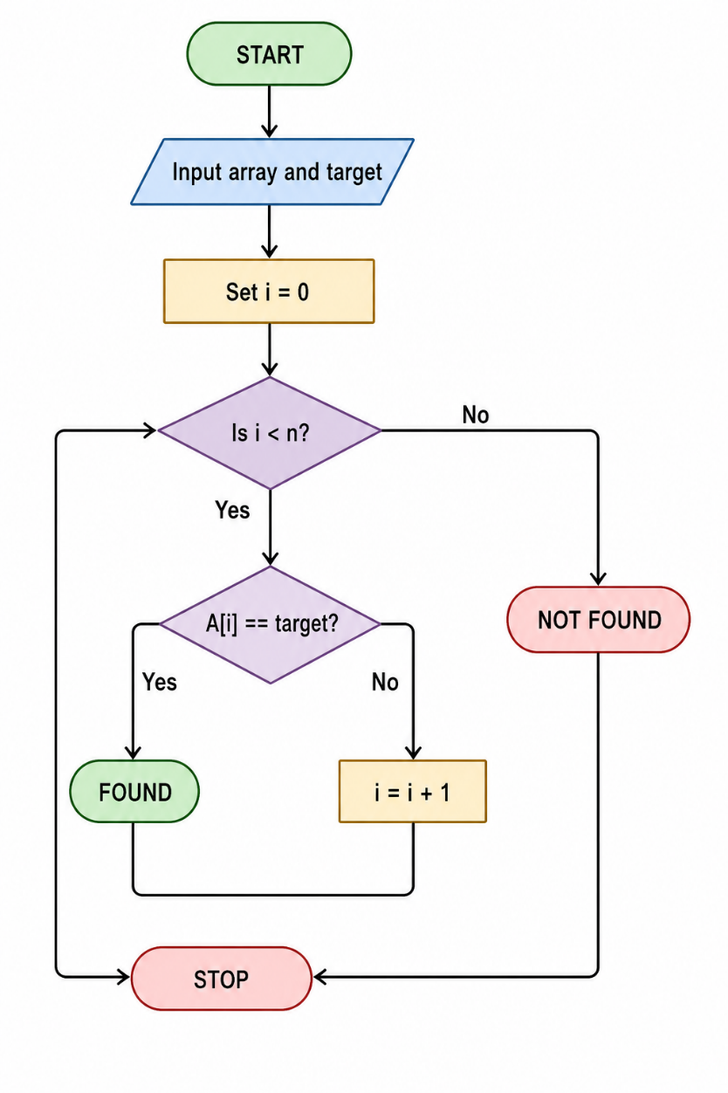
9. Flowchart

10. Step-by-Step Execution
Target = 34
Comparison 1
23 == 34?
No → Continue.
Comparison 2
45 == 34?
No → Continue.
Comparison 3
12 == 34?
No → Continue.
Comparison 4
67 == 34?
No → Continue.
Comparison 5
34 == 34?
Yes → Element found.
Search stops immediately.
Final Result
34 is found at position 5 (index 4).
Total comparisons = 5

11. Complexity Analysis
For a dataset of n elements:
Case | Situation | Comparisons | Time Complexity
Best Case | Target is first element | 1 | O(1)
Average Case | Target is somewhere in the middle on average | (n+1)/2 | O(n)
Worst Case | Target is last or absent | n | O(n)

For this dataset:
Average successful comparisons:
So the average case requires approximately 4 comparisons.

For the actual search:
Space Complexity
Linear Search uses only a few variables:

12. Correctness Analysis
The algorithm is correct because it checks every element sequentially.
Proof:
- The search starts at the first element.
- Each element is compared with the target 34.
- If the element is not equal to 34, the algorithm moves to the next element.
- When it reaches 34, the comparison is true.
- The algorithm returns its position.
Since:
the algorithm correctly identifies 34 at index 4.
Therefore, the result is correct.

13. Test Cases
Test Case | Target | Expected Result
1 | 34 | Found at position 5
2 | 23 | Found at position 1
3 | 10 | Found at position 7
4 | 50 | Not Found
5 | 67 | Found at position 4

14. Results
For the given dataset:
Dataset: [23, 45, 12, 67, 34, 89, 10]
Target: 34
Result:
- Target found: Yes
- Position: 5
- Zero-based index: 4
- Comparisons: 5
- Best-case complexity: O(1)
- Average-case complexity: O(n)
- Worst-case complexity: O(n)
- Space complexity: O(1)

15. Conclusion
Linear Search successfully finds 34 in the given unsorted dataset after 5 comparisons. It is simple, requires no sorting, and works well for small or unsorted datasets. However, its O(n) average and worst-case time complexity makes it inefficient for very large datasets. For large sorted datasets, algorithms such as Binary Search can provide much better performance.
Real-World Efficiency
Linear Search is useful when:
- The dataset is small.
- Data is unsorted.
- Searching is performed occasionally.
- Simplicity is more important than speed.
Examples include searching through a small contact list, checking a short list of products, or finding an item in a small collection. For very large datasets, databases and indexed search methods are generally more efficient.

